Best fruits and vegetables for dogs to eat
Humans love fruit and we know bananas and strawberries are good for us, but did you know they are good for your dogs, too? Not only will your dog love that he is getting “human food,” but you will love that the same benefits fruits provide us — aids in digestion, antioxidants, immunity boosts, better eyesight, healthier skin and hair — they also provide for your dog.

Apples
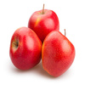
Source of potassium, fiber, phytonutrients, flavonoids, vitamins A and C. Note: Do not give dogs the core or the seeds, which contain arsenic. (Half of an apple slice is a good size treat). They are low in protein and fat, making them the perfect snack for senior dogs. Try them frozen for an icy warm weather snack.

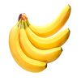
Bananas
They are high in potassium, vitamins, biotin, fiber, and copper. They are low in cholesterol and sodium, but because of their high sugar content, bananas should be given as a treat, not part of your dog’s regular diet

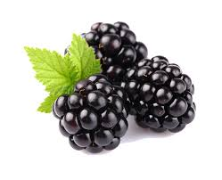
Blackberries
Source of antioxidants (anthocyanins), polyphenols, tannin, fiber, manganese, folate, omega-3. High in vitamins C, K, A and E. (Two or 3 blackberries is a good size treat.)

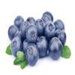
Blueberries
High in vitamins C, E, A and B complex. (2 or 3 blueberries is a good size treat.) Blueberries are a superfood rich in antioxidants, which prevent cell damage in humans and canines alike. They’re packed with fiber and phytochemicals as well. Try blueberries as an alternative to store-bought treats

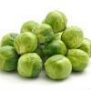
Brussel Sprouts
Dogs can eat brussels sprouts. Brussels sprouts are loaded with nutrients and antioxidants that are great for humans and dogs, alike. Don't overfeed them to your dog, however, because they can cause lots of gas.

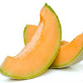
Cantaloupe
Source for vitamins A, B complex, C, plus fiber, beta-carotene, potassium, magnesium, thiamine, niacin, pantothenic acid and folic acid. (1 inch of cantaloupe wedge is a good size treat.) Cantaloupe is packed with nutrients, low in calories, and a great source of water and fiber. It is, however, high in sugar, so should be shared in moderation, especially for dogs who are overweight or have diabetes.

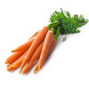
Carrots
Dogs can eat carrots. Carrots are an excellent low-calorie snack that is high in fiber and beta-carotene, which produces vitamin A. Plus, crunching on this orange veggie is great for your dog’s teeth

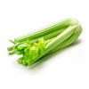
Celery
Celery is OK for dogs to eat. In addition to vitamins A, B, and C, this crunchy green snack contains the nutrients needed to promote a healthy heart and even fight cancer. As if that wasn’t enough, celery is also known to freshen doggy breath.

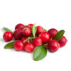
Cranberries
Source for vitamin C, fiber and manganese. Helps fight against urinary tract infections, plus balances acid-base in dog’s body. (2 tablespoons of stewed cranberries added to dog’s food is good size portion. Note: To stew cranberries, put them in a saucepan with water, cover and cook until tender. Put them through a sieve and add to dog food.) Both cranberries and dried cranberries are safe to feed to dogs in small quantities. Whether your dog will like this tart treat is another question. Either way, moderation is important when feeding cranberries to dogs, as with any treat, as too many cranberries can lead to an upset stomach

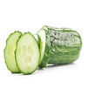
Cucumbers
Dogs can eat cucumbers. Cucumbers are especially good for overweight dogs, as they hold little to no carbohydrates, fats, or oils and they can even boost energy levels. They’re loaded with vitamins K, C, and B1, as well as potassium, copper, magnesium, and biotin

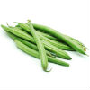
Green beans
Dogs can eat green beans. Chopped, steamed, raw, or canned – all types of green beans are safe for dogs to eat, as long as they are plain. Green beans are full of important vitamins and minerals and they're also full of fiber and low in calories.

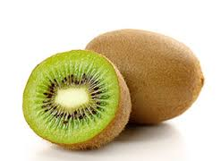
Kiwis
Source of fiber, potassium and high in vitamin C. (A half a slice or one slice of kiwi is a good size treat.)

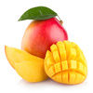
Mango
Dogs can eat mangoes. This sweet summer treat is packed with four, yes four different vitamins: vitamins A, B6, C, and E. They also have potassium and both beta-carotene and alpha-carotene. Just remember, as with most fruits, remove the hard pit first, as it contains small amounts of cyanide and can become a choking hazard

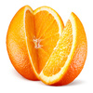
Oranges
Dogs can eat oranges. Oranges are fine for dogs to eat, according to veterinarians. They are also an excellent source of potassium, calcium, folic acid, iron, flavonoids, phytonutrients, vitamins A, C, B1 and B6. and fiber, and in small quantities can serve as tasty treats for your dog. Vets do, however, recommend tossing the peel and just giving your dog the inside of the orange, minus the seeds, as the peel is rough on their digestive systems.
Half of a segment is a good size treat. May cause stomach upset if fed in too big a portion. Do not feed your dog any part of the orange tree.

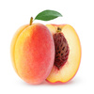
Peaches
Peaches are OK for dogs to eat. Small amounts of cut-up peaches are a great source of fiber and vitamin A, and can even help fight infections, but just like cherries, the pit contains cyanide. As long as you completely cut around the pit first, fresh peaches can be a great summer treat – just not canned peaches, as they usually contain high amounts of sugary syrups

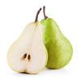
Pears
Dogs can eat pears. Pears are a great snack because they’re high in fiber, folic acid, niacin, phosphorus, potassium, copper, pectin and vitamins A, C, E, B1 and B2 and K, and fiber. It’s been suggested that eating the fruit can reduce the risk of having a stroke by 50 percent. Just be sure to cut pears into bite-size chunks and remove the pit and seeds first, as the seeds contain traces of cyanide. One or 2 cubes is a good size treat.

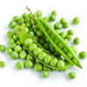
Peas
Green peas, specifically: snow peas, sugar snap peas, and garden or English peas are all OK for dogs. Peas have several vitamins, minerals, and are rich in protein and high in fiber. You can feed your dog fresh, frozen, or thawed peas, but do not give him canned peas, which have a lot of added sodium.

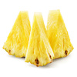
Pineapple
Pineapples are OK for dogs to eat. A few chunks of pineapple are a great sweet treat for dogs, as long as the prickly outside is removed first. The tropical fruit is full of vitamins, minerals, and fiber. It also contains bromelain, an enzyme that makes it easier for dogs to absorb proteins.

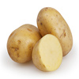
Potatoes
Dogs can eat potatoes. It’s fine to give your dog plain potatoes every once and a while, but only if they’re cooked, as raw potatoes can be rough on the stomach. A washed, peeled, plain boiled, or baked potato contains lots of iron for your dog. Avoid mashed potatoes because they often contain butter, milk, or seasonings.

Pumpkin
Source of fiber, beta-carotene, alpha-carotene, zinc, iron, potassium and Vitamin A.

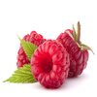
Raspberries
Dogs can eat raspberries. Raspberries are fine in moderation. They contain antioxidants that are great for dogs. They’re low in sugar and calories, but high in fiber, manganese, and vitamin C, K and B-complex. Raspberries are especially good for senior dogs because they have anti-inflammatory properties, which can help take pain and pressure from joints. However, they do contain slight amounts of the toxin Xylitol, so limit your dog to 2 or 3 raspberries.

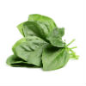
Spinach
Dogs can eat spinach, but it's not one of the top vegetables you'll want to be sharing with you pup. Spinach is very high in oxalic acid, which blocks the body’s ability to absorb calcium and can lead to kidney damage. While your dog would probably have to eat a very large amount of spinach to have this problem, it might be best to go with another vegetable.

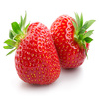
Strawberries
It is OK for dogs to eat strawberries. Source of fiber, potassium, magnesium, iodine, folic acid, omega-3 fats, vitamins C, K, B1 and B6.. Along with that, they also contain an enzyme that can help whiten your dog’s teeth as he or she eats them. They are high in sugar though, so be sure to give them in moderation. A half or 1 strawberry is a good size treat

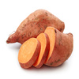
Sweet potatoes
Dogs can eat sweet potatoes. Sweet potatoes are packed with nutrients, including fiber, beta carotene, and vitamins B-6 and C. Just like with regular potatoes, only give your dog washed, peeled, cooked, and unseasoned sweet potatoes that have cooled down.

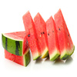
Watermelon
Watermelon is OK for dogs to eat. It’s important to remove the rind and seeds first, as they can cause intestinal blockage, but watermelon is otherwise safe for dogs. It’s full of vitamin A, B-6, and C, as well as potassium and magnesium. Watermelon is 92 percent water, so it’s a great way to keep your dog hydrated on hot summer days. 1 to 3 pieces of 1-inch watermelon wedge is a good size treat.

Tips for feeding fruit and vegetables to dogs

Give your dog small portions of fruit or vegetables only, especially the first time feeding them to your dog. Even though fruit is good for him, fruit is not calorie free. Also, you don’t know if your dog will have an allergic or other adverse reaction, such as gas or an upset stomach.

Clean fruit thoroughly before offering it to your dog.

If you can, introduce small portions of fruit to your dog when he is young. He may be more likely to try it and like it.

Some dogs don’t like raw fruit. Try mashing it into their food or adding it as an ingredient when you make homemade dog treats.

Avoid feeding your dog any type of seeds or pits. Although not all seeds are known to cause problems, it is better to be safe than sorry. What is known to be problematic or toxic are apple seeds, apricot pits, nectarine pits, plum pits, cherry pits and peach pits.

Fruit or vegetables that are not safe for dogs

Although some fruits in small portions can be good for your dog (unless your dog is allergic), never offer your dog the following. If your dog accidentally eats the below fruit, contact your veterinarian immediately.

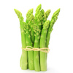
Asparagus
Dogs shouldn't eat asparagus. While asparagus isn’t necessarily unsafe for dogs, there’s really no point in giving it to them. It’s too tough to be eaten raw, and by the time you cook it down so it’s soft enough for dogs to eat, asparagus loses the nutrients it contains.

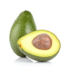
Avocado
Dogs should not eat avocado. While avocado may be a healthy snack for dog owners, it should not be given to dogs at all. The pit, skin, and leaves of avocados contain persin, a toxin that often causes vomiting and diarrhea in dogs. The fleshy inside of the fruit doesn’t have as much persin as the rest of the plant, but it is still too much for dogs to handle.

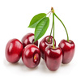
Cherries
Dogs shouldn't eat cherries. With the exception of the fleshy part around the seed, cherry plants contain cyanide and are toxic to dogs. Cyanide disrupts cellular oxygen transport, which means that your dog’s blood cells can’t get enough oxygen. If your dog eats cherries, be on the lookout for dilated pupils, difficulty breathing, and red gums, as these may be signs of cyanide poisoning.

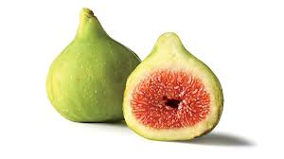
Figs
Figs have caused allergic reactions in some dogs. Also, the fig is grown on the Ficus tree (Ficus benjamina), which causes skin inflammation if your dog comes into contact with it. Ficus plants or trees also cause diarrhea and vomiting if your dog ingests them.
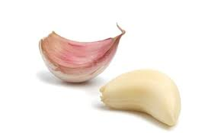
Garlic
While some argue there are benefits to feeding our dogs garlic, the Pet Poison Helpline warns that garlic is actually considered to be even more toxic than onions.. Symptoms of garlic toxicity include lethargy, elevated heart and respiratory rates, pale gums, and even collapse.

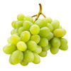
Grapes
Dogs should not eat grapes. Grapes and raisins have both proved to be very toxic for dogs no matter the dog’s breed, sex, or age. In fact, grapes are so toxic that they can lead to acute sudden kidney failure. Definitely skip this dangerous treat.

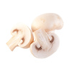
Mushrooms
Dogs should avoid mushrooms. Wild mushrooms can be toxic for dogs. While only 50 to 100 of the 50,000 mushroom species worldwide are known to be toxic, the ones that are can really hurt your dog or even lead to death. Washed mushrooms from the supermarket could be OK, but it’s better to be safe than sorry; skip out on the fungi all together.

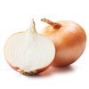
Onions
Dogs should not eat onions. Onions, leeks, and chives are part of a family of plants called Allium that is poisonous to most pets, especially cats. Eating onions can cause your dog’s red blood cells to rupture, and can also cause vomiting, diarrhea, stomach pain, and nausea. Poisoning from onions is more serious in Japanese breeds of dogs such as Akitas and Shiba Inus, but all dogs are very susceptible to it.
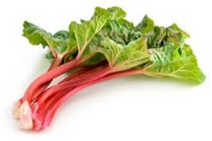
Rhubarb
Although this vegetable can make a delicious pie for humans, it should never be given to our canine friends. The leaves and stems of rhubarb depletes the calcium levels in our dogs’ bodies. This can result in renal failure as well as other medical problems.

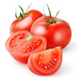
Tomatoes
Dogs should probably avoid tomatoes. While the ripened fruit of the tomato plant (the red part humans normally eat) is generally considered safe for dogs, the green parts of the plant contain a toxic substance called solanine. While a dog would need to eat a large amount for it to make him or her sick, it’s better to skip tomatoes all together just to be safe.

Remember other toxic substances are

Chocolate
Coffee or Tea
Xylitol
Macadamia nuts
Salt
Raw yeast dough
Alcohol
Mouldy food

